# EX.NO:1

**DATE: EXPLORETHEFEATURESOFMS-EXCEL. AIM:**

ToExplorethefeaturesofMs-Excel.

## F[eaturesofMSExcel](https://blogmedia.testbook.com/blog/wp-content/uploads/2021/06/microsoft-excel-79a119b7.png)

M[S Excel is used for processing the data that is in tabular form and thenperforming](https://blogmedia.testbook.com/blog/wp-content/uploads/2021/06/microsoft-excel-79a119b7.png)mathematical f[unctions on it to analyze it. This is what the Excel windowlooks like(version 2007):](https://blogmedia.testbook.com/blog/wp-content/uploads/2021/06/microsoft-excel-79a119b7.png)

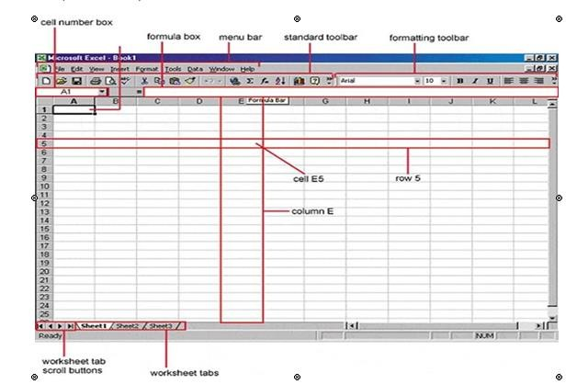

Excel is a tool for coordinating and performing calculations on data. It can examine data, compute statistics, create pivot tables, and express data as a chart or graph. MS Excel performs the following basic functions:

In MS Excel, there are rows and columns. The intersection of rows and columns makes a cell. So each of the cells is an individual unit of data. Each cellhasacelladdresswhichisthenumberofrowsandalphabetofthecolumn it appears in. No two cells have the same address ever.

## HomeandInsert

TheHome&InsertmenuofMSExcelissimilartoMSWord.Userscanchange the formatting of the content from home & include pie charts, tables, and other files related to data from the insert menu.

Fontsize,fontcolor,fontstyles,alignment,backgroundcolor,formattingoptions and styles, insertion, deletion, and editing in the cells options are also available.

Onecaninsertimagesandfigures,header,andfooter,charts,andsparklinesand even attach graphs, equations, and symbols.

## Formulas

TheuniquefunctionsthatMSExcelhasareFormulas&Data.Userscanperform the formula on data to analyze it quickly. Users have to select the cells for that and one cell becomes one unit of data.

So,iftheuserselects10cellsandappliesanaverageformulatothem,theuserwill get an average of the data output of those 10 cells.

To apply a formula to any data, the user needs to select it without any space. Then inthefunctionbar,theuserneedstotype‘=’andthe abbreviationoftheformulatheuser wishes to apply.

## Data

From the Data menu, the user can perform functions without changing the original data. Users can filter, add external data from the web & sort data without changing it. For example, the user can sort the data in alphabetical order.

## PageLayout

Userscanapplythemes,orientation,andcheckthepagesetupthroughthepagelayout option.

## Review

Proofreadinglikespellcheckcanbeperformedforanexcelsheetinthereviewsection and a user can even add comments or remarks in this part.

## View

Differentviewsandlayoutsinwhichtheuserwantsthespreadsheettobedisplayedcan be selected here. Options to zoom in and out, full screen, and pane arrangement are available under this section.

ThereareseveralfeaturesthatareavailableinExceltomakeourtaskmore manageable. Some of the main features are:

1. 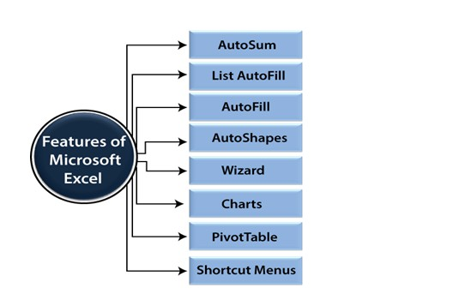AutoFormat:Itallowstheexceluserstousepredefinedtableformattingoption.
2. AutoSum: AutoSum feature helps us to calculate the sum of a row or column automatically by inserting an addition formula for a range of cells.
3. List AutoFill: It automatically develops cell formatting when a new component is added to the end of a list.
4. AutoFill: This feature allows us to quickly fill cells with a repetitive or sequential record such as chronological dates or numbers and repeated documents. AutoFill can also be used to copy functions. We can also alter text and numbers with this feature.
5. AutoShapes: AutoShapes toolbar will allow us to draw some geometrical shapes, arrows,flowchartitems,stars,andmore. Withtheseshapes,wecandrawour graphs.
6. Wizard: It guides us to work effectively while we work by displaying several helpful tips and techniques based on what we are doing. Drag and Drop feature will help us to reposition the record and text by simply dragging the data with the help of the mouse.
7. Charts: This feature will help you to present the data ingraphical form by using Pie, Bar, Line charts, and more.
8. PivotTable: It flips and sums data in seconds and allows us to execute data analysis and generating documents like periodic financial statements, statistical documents, etc. We can also analyze complex data relationships graphically.
9. Shortcut Menus: The shortcut menu helps users to make the work done

# RESULT:

TheExplorethefeaturesofMs-Excelissuccessfully.

AIM:

**EX.NO:02 (i**)

**DATE:**

**GETTHEINPUTFROMUSERANDPERFORMNUMERICAL**

**OPERATIONS(MAX,MIN,AVG,SUM,SORT,ROUND)**

Togettheinputfromuserandperformnumericaloperations(MAX,MIN,AVG, SUM,SORT,ROUND)

# PROCEDURE:

Let’sconsiderthefollowingdata:

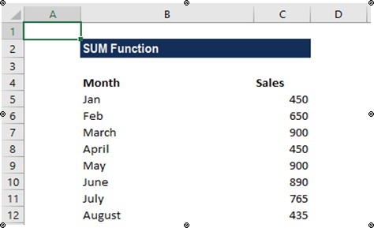

**Step-1**:SelectaSampleExceldatasheet

**Step-2:**Performfollowingoperations

* 1. Sum:

AddingTwoManualEntries

* + - TypeA1(=)
    - Type5+5
    - Hitenter

## AddingTwoCells

Selectacellandtype(=)Selecta cell

Type(+)

SelectanothercellHitenter

## AddingSeveralCells

Formula:=SUM(number1,[number2],[number3]……)

1. TypeB1(=SUM)
2. DoubleclicktheSUMcommand
3. MarktherangeA1:A5
4. Hitenter

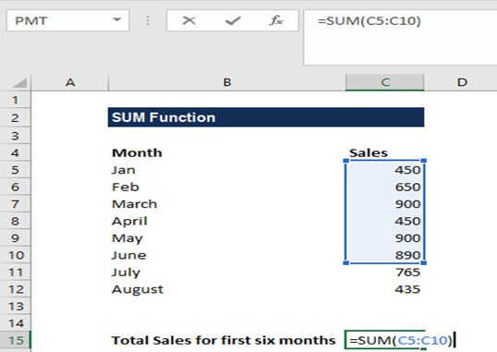

## We get the output below:

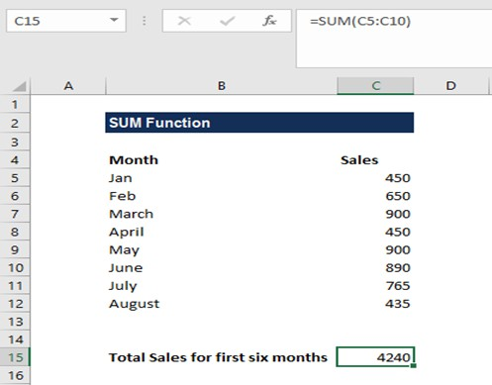

**AddingUsingAbsoluteReference:**

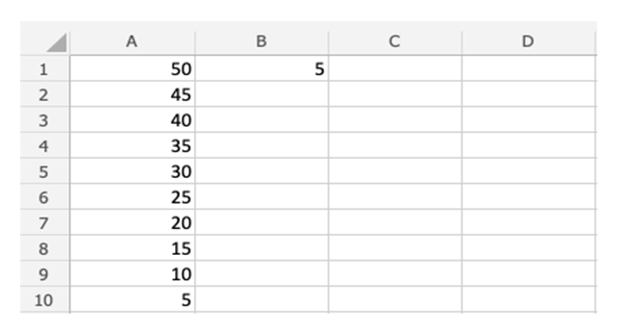

1. Selectacellandtype (=)
2. Selectthecellyouwanttolock,addtwo-dollarsigns($)beforethecolumnand row
3. Type(+)
4. Fillarange

## Stepbystep:

1. TypeC1(=)
2. SelectB1
3. Typedollarsignbeforecolumnandrow $B$1
4. Type(+)
5. SelectA1
6. Hitenter
7. FilltherangeC1:C10

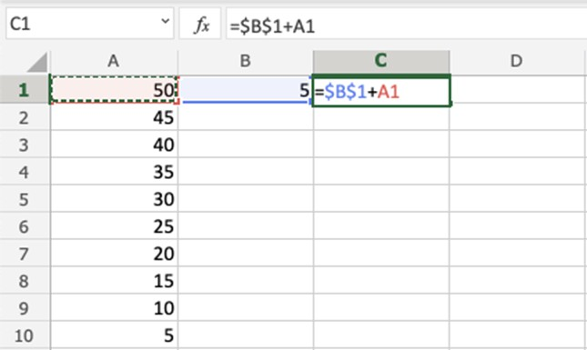

## MAXFunction

TheMAXfunctionisapremadefunctioninExcel,whichfindsthe highest number in a range.It is typed =MAX

Thefunctionignorescellswithtext.Itwillonlyworkforcellswithnumbers.

## Howtousethe=MAXfunction:

SelectacellType

=MAX

Doubleclickthe MAXcommand Select a range Hitenter

## MINFunction

The**MIN**functionisapremadefunctioninExcel,whichfinds the lowest number ina range. It is typed =MIN

Howtousethe=MINfunction:

* 1. Selectacell
  2. Type=MIN
  3. Doubleclickthe**MIN**command
  4. Selectarange
  5. Hitenter

## AVERAGEFunction

The**AVERAGE**functionis a premadefunctioninExcel,whichcalculatesthe average(arithmetic mean).

Itistyped=AVERAGE

Itaddstherangeanddividesitbythenumberofobservations.

**Note:**The**AVERAGE**functionignorescellswithtext.

* 1. Selectacell
  2. Type=AVERAGE
  3. Doubleclickthe**AVERAGE**command
  4. Selectarange
  5. Hitenter
  6. Next,Fill

## C. findingsquarerootusingSQRTFunction

SQRT(number).Where*number*isthenumberorreferencetothecellcontaining the number for which you want to find the square root.

TocalculatesquarerootofanumberinA2,usethisone:**=SQRT(A2)**

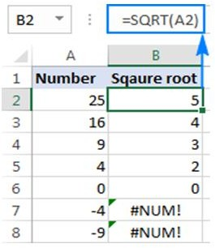

## f.ROUNDFunction

TheROUNDFormulainExcelacceptsthefollowingparametersandarguments:

**Number–**Thenumberwhichhastoberounded.

**Num_Digits–**Thetotalnumberofdigitstoroundthenumberto.

|  |  |  |
| --- | --- | --- |
| Formula | **Result** | **Description** |
| =ROUND(A2,2) | 106.86 | ThenumberinA2isroundedto2decimalplaces. |
| =ROUND(A2,1) | 106.9 | ThenumberisA2isroundedto1decimalplace. |
| =ROUND(A2,0) | 107 | Thenumber in A2isrounded to thenearest integer. |
| =ROUND(A2,-1) | 110 | The numberin A2 isrounded to the nearest multiple of 10. |
| =ROUND(A2-2) | 100 | The numberin A2 isrounded tothenearest multiple of 100. |

# RESULT:

Theprogramofgettheinputfromuserandperformnumericaloperations(MAX

,MIN,AVG,SUM,SORT,ROUND)issuccessfully.

# AIM:

**EX.NO:02(ii)**

**DATE:**

**PERFORMDATAIMPORT/EXPORTOPERATIONSFOR**

**DIFFERENTFILEFORMATS**

ToPerformdataimport/exportoperationsfordifferentfileformats.

# PROCEDURE:

## Step1:ExportData

Whenyouhavedatathatneedstobetransferredtoanothersystem,exportitfrom Excel in aformat that can be interpreted by other programs, such as a text or CSV file.

1. Clickthe**File**tab.
2. Attheleft,click**Export**.
3. Clickthe**ChangeFileType**.
4. UnderOtherFileTypes,selectafiletype.
   * **Text(Tabdelimited):**Thecelldatawillbeseparatedbyatab.
   * **CSV(Commadelimited):**Thecelldatawillbeseparatedbyacomma.
   * **FormattedText(spacedelimited):**Thecelldatawillbeseparatedbya space.
   * **SaveasAnotherFileType:**Selectadifferentfiletype when the Save Asdialog box appears.

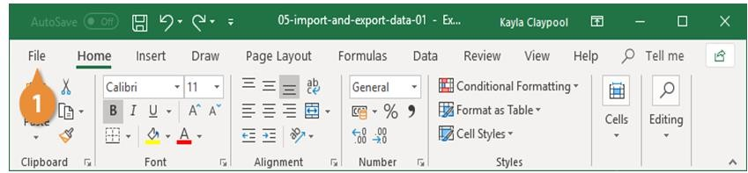

Thefiletypeyou select will dependonwhattypeoffileisrequiredbytheprogram that willconsume the exported data.

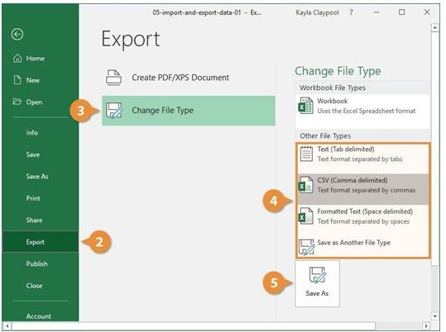Click**SaveAs**.

Sp eci fy wh ere yo u

wanttosavethefile.ClickSave.

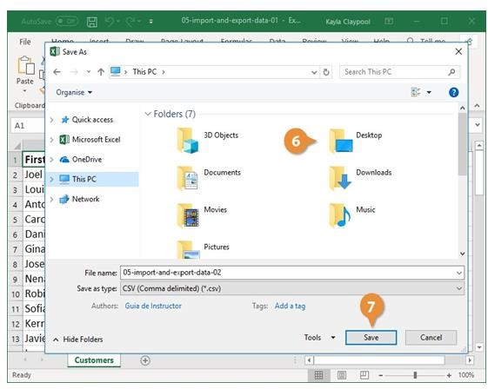

Adialogboxappearsstatingthatsomeoftheworkbookfeaturesmaybelost.Click**Yes**.

## Steap2:ImportData

Excelcanimportdatafromexternaldatasourcesincludingotherfiles, databases, or webpages.

1. Clickthe**Data**tabontheRibbon..
2. Clickthe**GetData**button.

Some data sources may require special security access, and the connection process can often be very complex. Enlist the help of your organization’s technical support staff for assistance.

1. Select**FromFile**.
2. 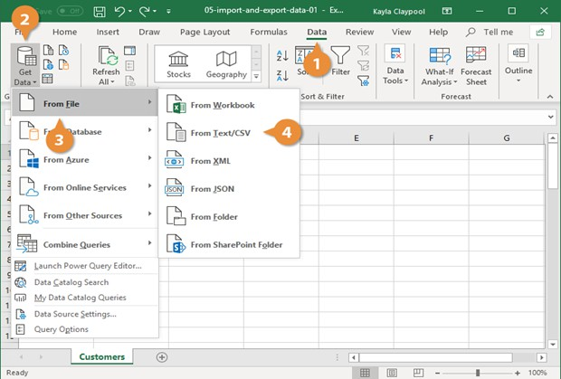Select**FromText/CSV**.
3. Selectthefileyouwanttoimport.
4. Click**Import**.

If,whileimportingexternaldata,asecuritynoticeappearssayingthatitis

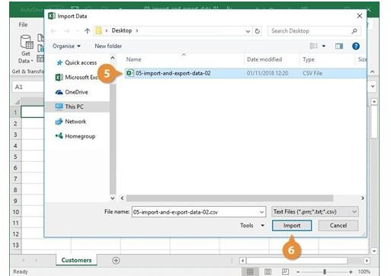

connectingtoanexternalsourcethatmaynotbesafe,click**OK**.

1. Verifythepreviewlookscorrect.
2. Click**Load**.

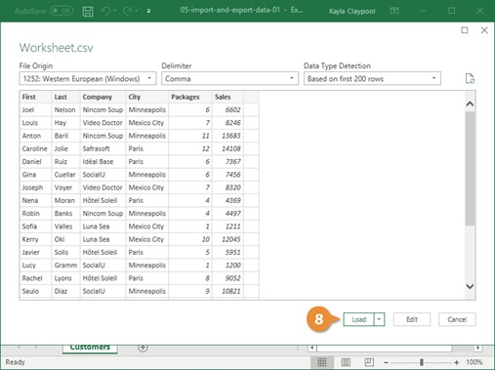

# RESULT:

ThePerformdataimport/exportoperationsfordifferentfileformatsis successfully.

# AIM:

**EX.NO:03**

**DATE:**

**MEAN,MEDIAN,MODEANDSTANDARDDEVIATION,**

**VARIANCE,SKEWNESS,KURTOSIS**

Toperformstatisticaloperations:Mean,Median,ModeandStandarddeviation,

Variance,Skewness,Kurtosis

# PROCEDURE:

**Step 1:** If you haven't already installed the Analysis ToolPak , Click the MicrosoftOfficebutton,thenclick on the Excel Options , and then select Add-Ins , Click Go,check the AnalysisToolPak box, and click Ok.

**Step2:**SelectDatatab,thenclickontheDataAnalysisoption,thenselects DescriptiveStatistics from the list and Click Ok. [Data tab >> Data Analysis >> Descriptive Statistics]

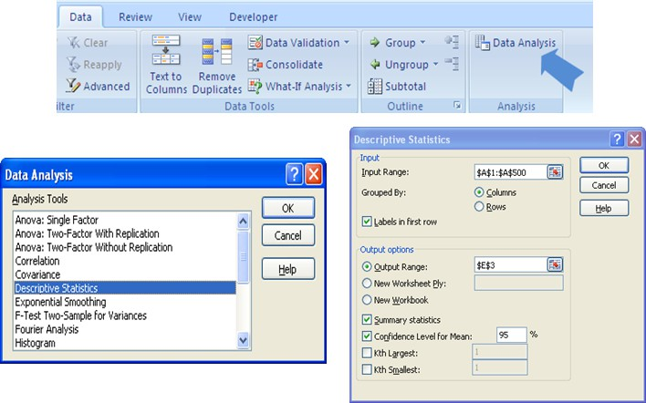

**Step3:**Inthe**InputRange**weselectthedata,andthenselect**OutputRange**where youwantthe output to be stored. *If you don’t specify the output range it will throw output in the new worksheet.*

**Step4:**Check**Summary Statistics**and**Confidence Level for Mean**options. By default theconfidencelevelis95%.Youcanchangethelevelasperthehypothesis standard of study.

**Step 5:** When you click **Ok**, you will see the resultin the selected output range.

# OUTPUT:

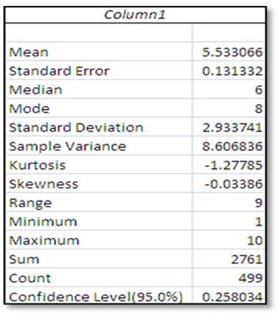

**RESULT:**

Theperformstatisticaloperations:Mean,Median,ModeandStandarddeviation, Variance, Skewness, Kurtosisis successfully

# AIM:

**EX.NO:04**

**DATE:**

**PERFORM Z-TEST,T-TEST&ANOVA**

ToPerform Z-test,T-test&ANOVA

# PROCEDURE:

StepstoperformZTESTin Excel:

*Let’sconsiderthebelowdata;*

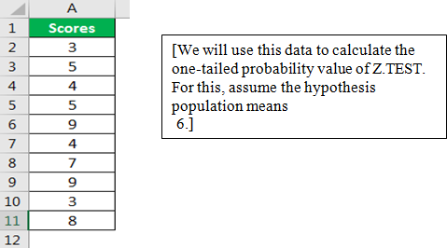

**Step1:**OpentheZ.TESTformulainanExcelcell

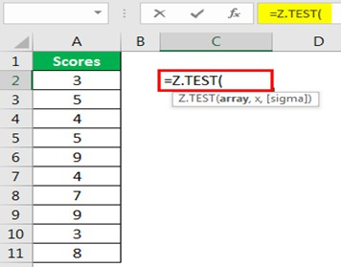

**Step2:**Selectthearrayasscores***,A2toA11***

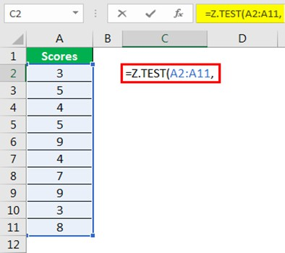

**Step3:**Thenextargumentis“x.”Sincewehavealreadyassumedthehypothesized population mean is6, apply this value to this argument

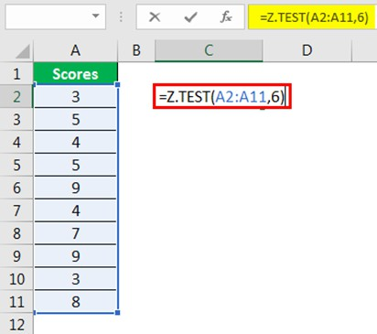

**Step4:**Thelastargumentisoptional,soclosetheformulatogettheZ.TESTvalue.

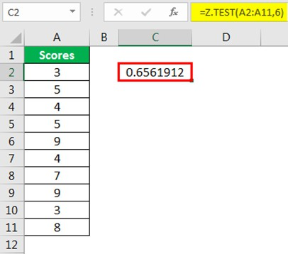

**Step5:**Itisaone-tailedZTESTvaluetogetthetwo-tailedZ.TESTvaluetomultiplythis value by 2

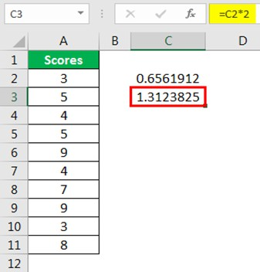

## StepstoperformTTEST:(tofindp-value)

*Considerthebelowdata;*

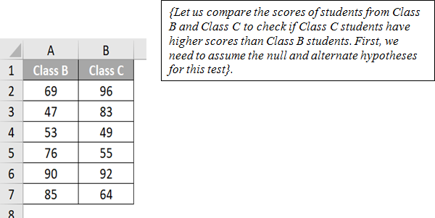

**Step1:**Select**cellB9**andwritethebelowformula:

# =T.TEST(A2:A7,B2:B7,1,2)

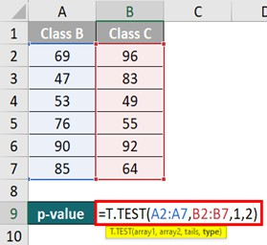

**Step2:**Press“Enter,”andExcelwillcalculatethep-valueas**0.38692**in**cellB9**.

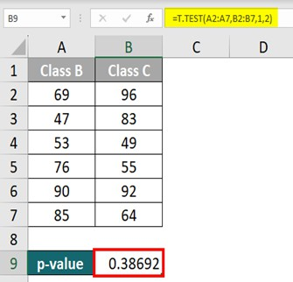

**StepstoperformANOVA;*Let’sconsiderthebelowdata:***

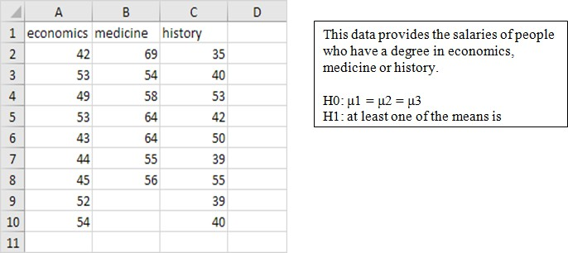

**Step1:**OntheDatatab,intheAnalysisgroup,clickDataAnalysis.

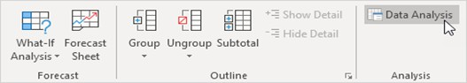

**Step2**:SelectAnova:SingleFactorandclickOK.

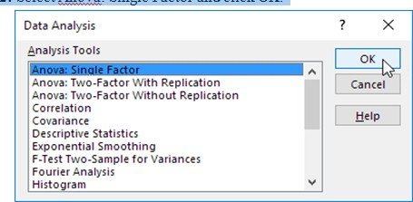

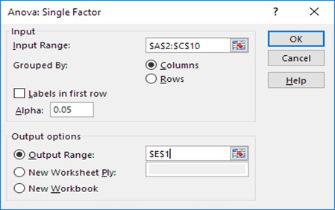

**Step3:**ClickintheInputRangeboxandselecttherange **A2:C10**.

**Step4:**ClickintheOutputRangeboxandselect**cellE1**. **Step 5:** Click OK to view the results.

# OUTPUT:

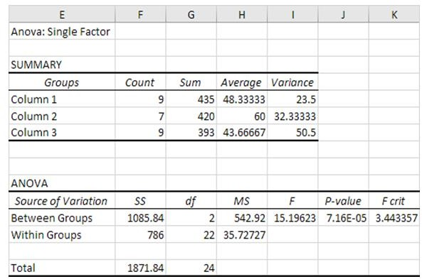

**RESULT:**

The Perform Z-test,T-test&ANOVAissuccessfully.

# AIM:

**EX.NO:05**

**DATE:**

**DATAPREPROCESSINGOPERATIONSONHANDLINGMISSING**

**DATA,NORMALIZATION**

ToPerformdatapreprocessingoperationsonhandlingmissingdata,Normalization

# PROCEDURE:

## HandlingMissingData

* Identifythecolumnswithmissingdata.
* Decidehowtohandlethemissingdata.Somecommonoptionsinclude:
  + Deletingtherowswithmissingdata.
  + Imputingthemissingvalueswithmean,median,ormodeofthecolumn.
  + Usingamoresophisticatedimputationmethod,suchas regressionimputation.
* Toimputethemissingvalueswiththemeanofthecolumn,youcanuse the followingformula:=IF(ISBLANK(A2),AVERAGE(A:A),A2)
* ORgotoXLMINER>Transform>Missingdatahandlingandfillthemissingvalues

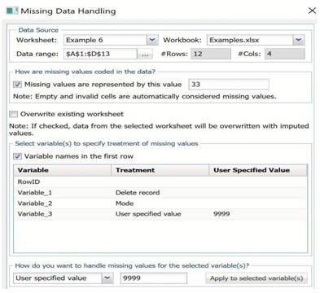

## Normalization

* Identifythecolumnsthatneedtobenormalized.Normalizationistypicallyusedfor numerical columns, such as height, weight, and age.

Chooseanormalizationmethod.Somecommonmethodsinclude:

* Min-maxnormalization:Thismethodscalesthedatasothatthesmallestvalueis0and the largest value is 1.
* Z-scorenormalization:Thismethodscalesthedatasothatthemeanis0andthestandard deviation is 1.
* Decimalscaling:Thismethodscalesthedatasothatthelargestdecimalplaceis2.
* Implementthechosenmethod.Forexample,toperformmin-maxnormalization,you can use the following formula:=(A2-MIN(A:A))/(MAX(A:A)-MIN(A:A))

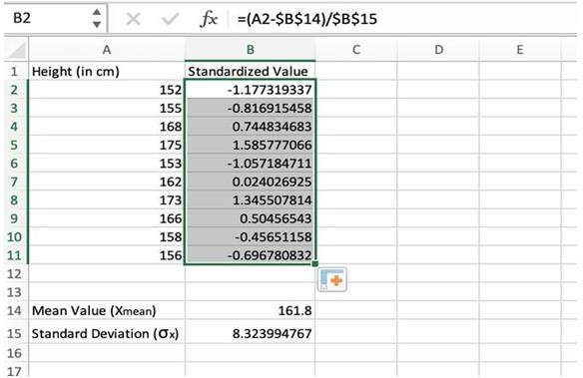

# RESULT:

ThePerformdatapreprocessingoperationsonhandlingmissingdata,Normalization is successfully.

# AIM:

**EX.NO:06**

**DATE:**

**DIMENSIONALITYREDUCTIOMOPERATIONUSINGPCA,KPCA&SVD**

ToperformdimensionalityreductiomoperationusingPCA,KPCA&SVD

# PROCEDURE:

**PCA**

1. OpenthedatasetinExcel.
2. SelecttheDatatabandthenclicktheDataAnalysis button.
3. IntheDataAnalysisdialogbox,selectPrincipalComponentAnalysisandthen click OK.
4. InthePCAdialogbox,selectthedatarangeandthenclickOK.
5. ThePCAoutputwillbedisplayedinanewworksheet.

# KPCA

1. OpenthedatasetinExcel.
2. InstalltheXLSTATpluginforExcel.
3. SelecttheXLSTATtabandthenclicktheDataAnalysisbutton.
4. IntheDataAnalysisdialogbox,selectKernelPrincipalComponent Analysis and then clickOK.
5. IntheKernelPCAdialogbox,selectthedatarangeandthekernel type.
6. ClickOK.
7. TheKPCAoutputwillbedisplayedinanew worksheet.

# SVD

1. OpenthedatasetinExcel.
2. SelecttheDatatabandthenclicktheDataAnalysis button.
3. IntheDataAnalysisdialogbox,selectSingularValueDecompositionandthen click OK.
4. IntheSVDdialogbox,selectthedatarangeandthenclickOK.
5. TheSVDoutputwillbedisplayedinanewworksheet

# OUTPUT:

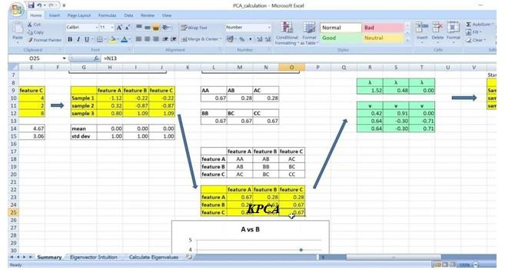

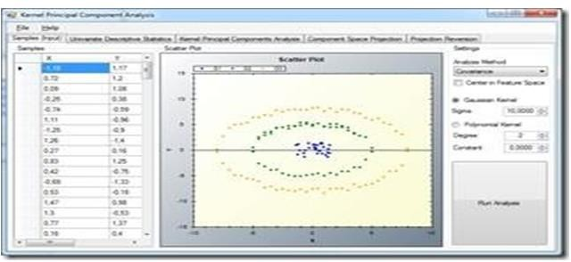

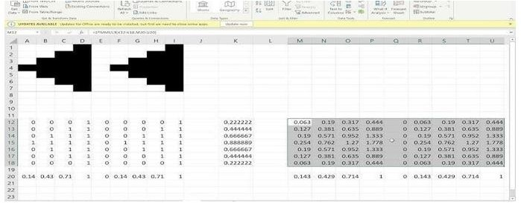

**RESULT:**

TheperformdimensionalityreductiomoperationusingPCA,KPCA&SVD is successfully.

# AIM:

**EX.NO:07**

**DATE:**

**PERFORMBIVARIATEANDMULTIVARIATEANALYSIS ONTHE DATASET**.

Toperformbivariateand multivariateanalysisonthedataset.

# PROCEDURE:

## ToperformbivariateandmultivariateanalysisinExcel,followthesesteps:

1. OpenthedatasetinExcel.
2. Identifythevariablesthatyouwanttoanalyze.
3. Choosetheappropriate bivariateormultivariateanalysis technique.
4. PerformtheanalysisusingthecorrespondingExcelfunction.
5. Interprettheresultsoftheanalysis.

## BivariateAnalysis

Bivariateanalysisisthestudyoftherelationshipbetweentwovariables.Itcanbeused toidentify patterns, correlations, and trends in the data.

ThereareavarietyofbivariateanalysistechniquesthatcanbeusedinExcel,including:

* + Scatterplots
  + Correlationcoefficients
  + Linearregression

## MultivariateAnalysis

Multivariateanalysisisthestudyoftherelationshipbetweenthreeormorevariables.It can beused to identify patterns, correlations, and trends in the data that are not visible when examining the variables individually. There are a variety of multivariate analysis techniques that can be used in Excel, including:

* + Principalcomponentanalysis(PCA)
  + Factor analysis
  + Clusteranalysis

# OUTPUT:

**BivariateAnalysis**

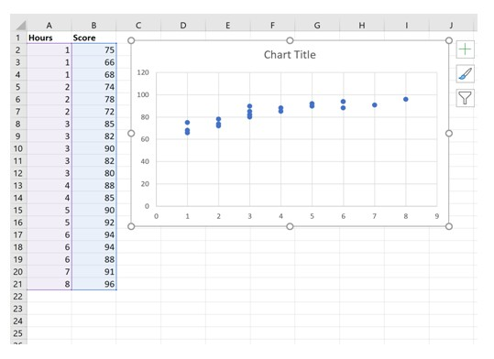

**MultivariateAnalysis**

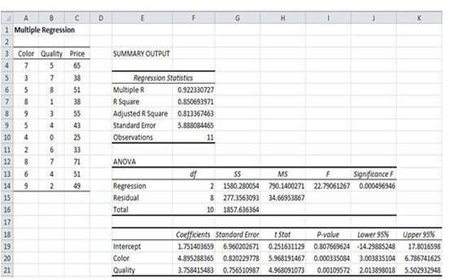

# RESULT:

Toperformbivariateand multivariateanalysisonthedatasetissuccessfully.

# AIM:

**EX.NO:08**

**DATE: APPLYANDEXPLOREVARIOUSPLOTTINGFUNCTIONSONTHEDATASET**.

Toapplyandexplorevariousplottingfunctionsonthedata set.

# PROCEDURE:

**Step1:**OpentheExcelworkbookthatcontainsthedatasetthatyouwanttoplot.

**Step2:**Selectthedatathatyouwantto plot.

**Step 3:** Click on the Insert tab and then select the type of chart or graph that you want to create.

**Step 4:** In the Chart Wizard dialog box, select the options that you want for your chart or graph.

**Step5:**ClickontheFinishbuttontocreatethechartor graph.

# OUTPUT:

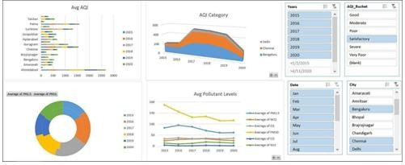

**RESULT:**

Theapplyandexplorevariousplottingfunctionsonthedatasetissuccessfully.

# AIM:

**EX.NO:09**

**DATE:**

**EXPLORETHEFEATURESOFPOWERBIDESKTOP**

ToexplorethefeaturesofpowerBIDesktop.

**PROCEDURE:**

**Step1:**InstallPowerBIDesktop.

Visit<https://powerbi.microsoft.com/en-us/downloads/>

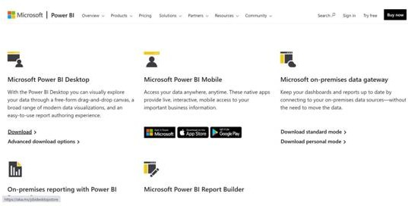

**Step2:**SelectDownloadfromMicrosoftPowerBIDesktop

WecanseethebelowscreenafteropeningthePowerBIDesktop.

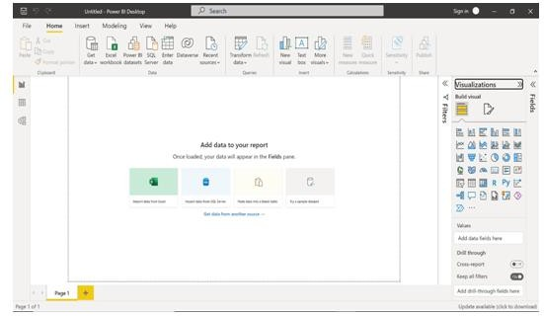

**Step3**:Explorethefeatures.

GetData(Data Source)

In the Home tab, from the Get data option, we can get data from various data sources such as Excel workbook, Text/CSV, SQL Server, Power BI datasets, Power BI dataflows, Web,ODatafeed,AnalysisServices,Parquet,SharePointfolder,AzureBlobStorage,Azure Databricks, MariaDB, etc.

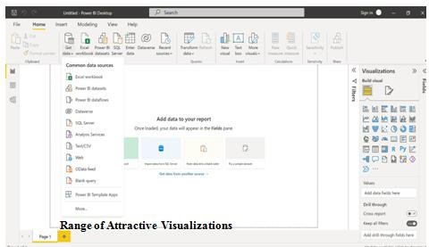

* WecanaddvisualstothereportpagebyclickingtheNewvisualoption.
* youcancreatereportsanddashboardsusingassimpleorascomplexvisualizationsas you want to represent your data set with.
* Thereisalsoalibraryavailableforcustomvisualizations.
* InPowerBIwecancreatevisualssuchas;Ribbonchart,Waterfallchart,Scatterchart, Pie chart, Map, Filled map, Funnel chart, Clustered bar chart, Gauge chart, et cetera…

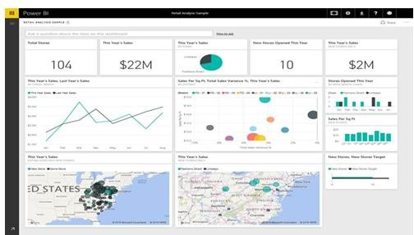

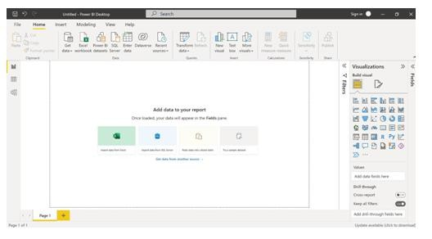

## TextBox

WiththeTextboxoption,wecaninsertatextboxinthereportpageandsetthe font type and font size for the text visual.

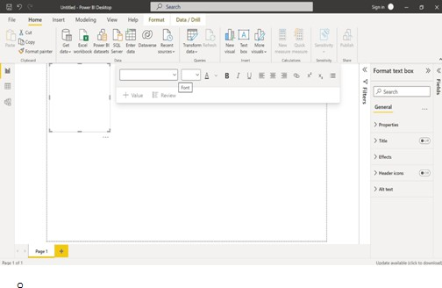

IntheInserttab,fromtheTextboxoption,wecaninsertatextboxinthereport page and set the font type and font size for the text visual.

Using the Shapes option, we can insert shapes like block arrows pointing to different directions and basic shapes such as circles, ovals, lines, pentagons, hexagons, etcetera…

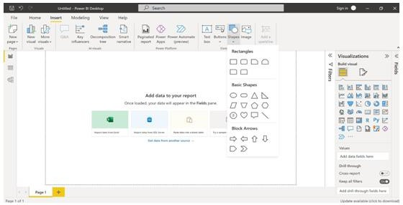

Filtersandbookmarksoptions

UsingFiltersandbookmarksoptions,theusercanapplyfiltersand bookmarkstothe Power BIReport.

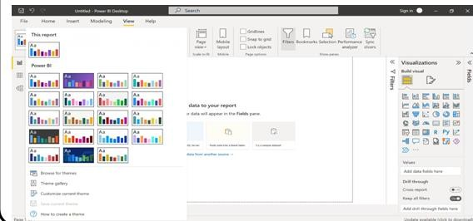

# RESULT:

TheexplorethefeaturesofpowerBIDesktopis successfully.

# AIM:

**EX.NO:10**

**DATE:**

**PREPAREANDLOADDATA**

**ToPrepareandloaddata**

# PROCEDURE:

## Step1:OpenPowerBIDesktop:

LaunchthePowerBIDesktopapplication.

## Step2:ConnecttoData Source

ClickonGetdataintheHometab,thenselectExcelworkbook,now choose the downloadedexcel file and open it.

## Step3:Select Data

IntheDataSourceNavigator,choosethetablesordataobjectsyouwantto import.

(Users can import data from Azure Synapse Analytics SQL, Excel, Text/CSV, Web, AmazonRedShift, Oracle, MySQL, Snowflake, SAP databases,GoogleBigQuery,MariaDB,SharePointList,etc.,inPower BI Desktop based on their requirements.)

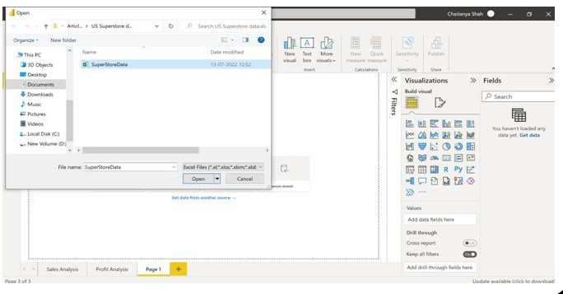

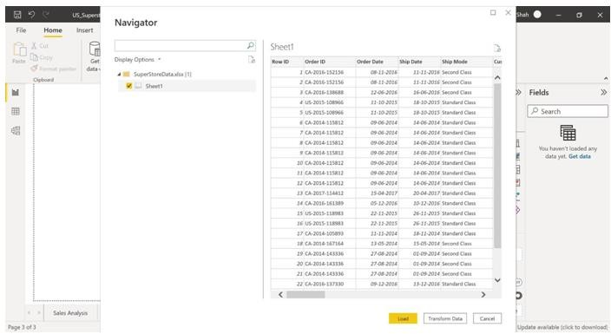

## Step5:DataTransformation(Optional):

Ifneeded,usethePowerQueryEditortoclean andtransformthedata.Ex; (Shaping and Cleaning data)

1. RightClickSheet1->Rename.RenameittoOrders.
2. RightClickOrderID->RemoveEmpty.
3. Right Click Order Date -> Date filters -> Between -> Filter Rows tab selectAdvancedradiobutton->Select05-08-2014indatepicker parallel to is after or equal to -> Select11-05-2016 in date picker parallel to is before or equal to.
4. Right Click Quantity -> Number filters -> Greater than or equal to -> FilterRowstabselectBasicradiobutton->Select2indrop-down parallel is greater than or equal to ->OK

# OUTPUT:

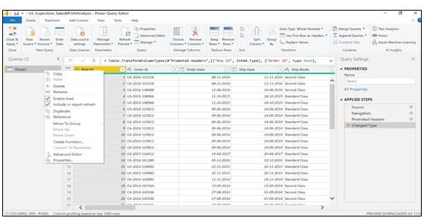

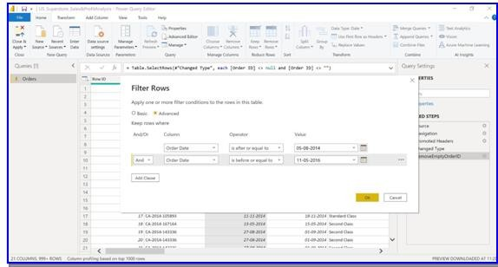

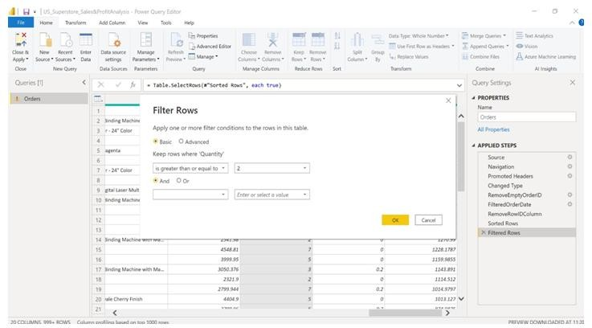

**RESULT:**

TheprogramisPrepareand load dataissuccessfully.

# AIM:

**EX.NO:11**

**DATE:**

**DEVELOPTHEDATAMODEL**

Todevelopthedatamodel

# PROCEDURE:

**Step1:**LaunchPowerBIDesktop

**Step2:**OntheDashboardwindowclick***File***

**Step3:**Then,click***Optionsandsettings->Options->CurrentFile***

**Step4:**Nextup,loadthedatabyselecting**DataLoad**option

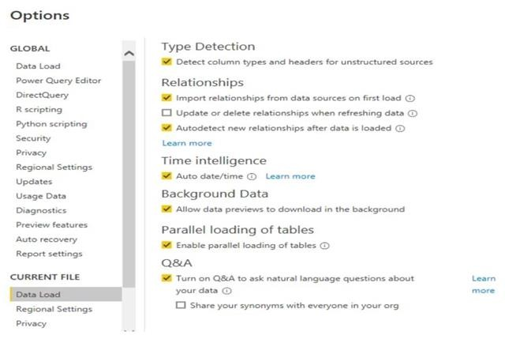

**Step5:*Upload***theCSVfilestoyourPowerBIdashboardbyclickingthe ***“Get data”*** option from thetop menu and then selecting ***“Text/CSV”*** option from the dropdown list**.**

**Ex;**forthisexperimentwe’veimportedthebelowcsvfile;

*https://files.grouplens.org/datasets/movielens/ml-latest-small.zip*

(YouwillseethefourCSVfilesintheformoftablesandtheircorresponding columns in the ReportsView as shown)

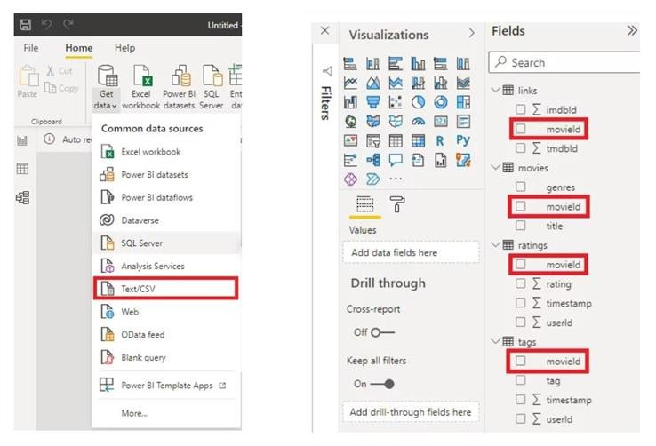

**Step6:***Finally,*todisplaythePowerBIModel,clickthe ***“Model”***iconfrom the left menu bar on theReports view.

# OUTPUT:

**RESULT:**

TheprogramonPrepareandloaddataissuccessfully.

# AIM:

**EX.NO:12**

**DATE:**

**PERFORMDA CALCULATIONS**

ToperformDAcalculations

# PROCEDURE:

InPowerBI,DAXcanbeusedtoconstructtwodistinctkindsofexpressionsand calculations:

* 1. Calculatedcolumns
  2. Calculatedmeasures

Stepstocreate**CalculatedColumns:**

**Step1:**LaunchPowerBIdesktop

**Step2:**Prepareandimportthedata(csvfile)

**Step3:**InthePowerBIDesktopleftpane,selectthe***Datatab***

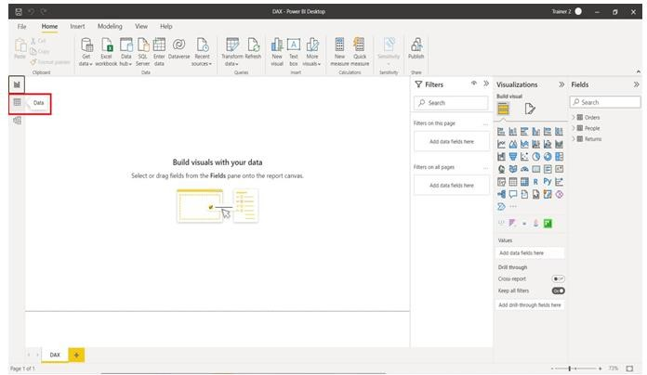

**Step4:**Next,clickthe***NewColumn***button

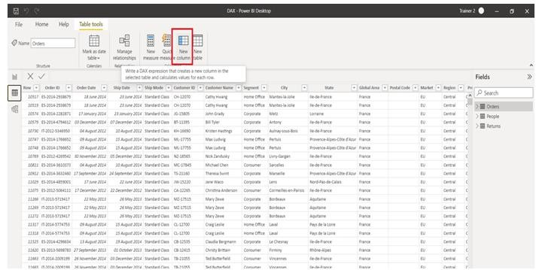

**Step5:IntheFormulabar,enter*“Column=”*andhitenter.**

Stepstocreate**CalculatedMeasure:**

**Step1:**LaunchPowerBIdesktop

**Step2:**GotoPowerBIModelingsection

**Step3:**Nextup,choosethe***“NewMeasure”***menuitem

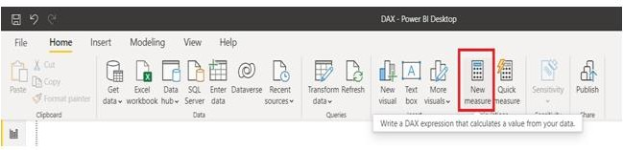

**Step4:**Thewords***“Measure=”***willappearinaFormulaswindow

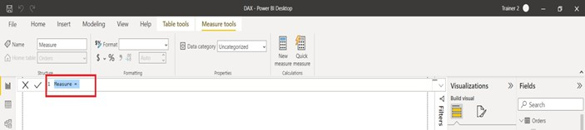

**Step5:**Youcanchange*“Measure”*toanyothernameforaunitofmeasurement

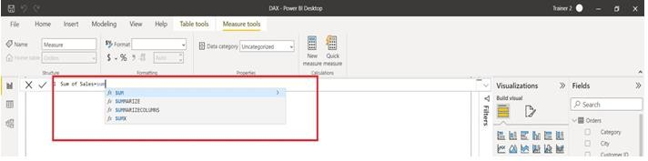

**Step6:Next,type theexpressionforthe resultant sizetotheright oftheequals sign.**

# OUTPUT:

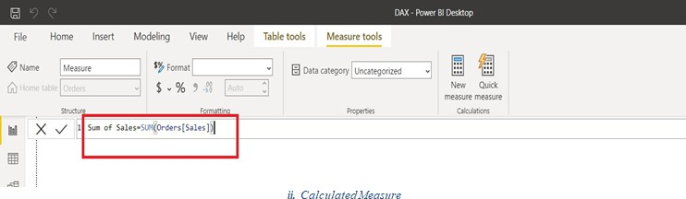

**RESULT:**

ToperformDAcalculations is successfully.

# AIM:

**EX.NO:13**

**DATE:**

**DESIGNAREPORTAANALYST**

Todesignareportaanalyst

# PROCEDURE:

**Step1:**LauchPowerBIdesktop

**Step2:**Nextup,impotandtransformthedataset

(Ex;here,we’llbeusingthe**“RetailAnalysisSample”**preparedbyMicrosoft and Obvience)

**Step3:***go*tothe**“Datasets”**sectionin yourworkspaceand *click*the**‘Createreport’ icon**.

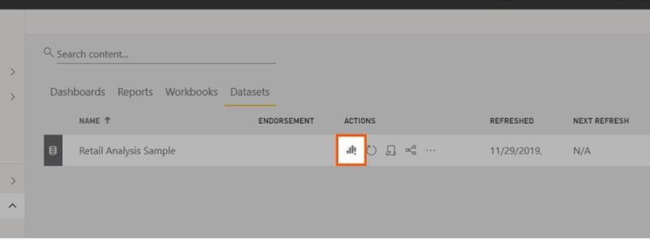

**Step 4:** Select the ***fields*** first then visualizations after [*Select***“Sales”**andthen**“TotalUnitsThisYear”**]

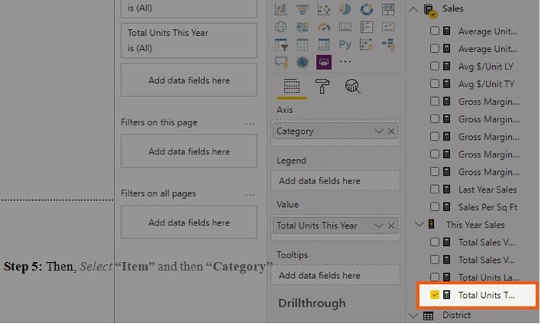

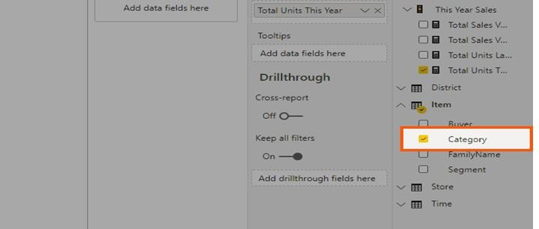

**Step5:**ForVisuals,headovertothevisualizationspaneand*click*the**piecharticon**

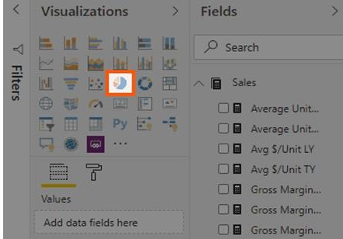

**Step6:**Modifying;

* ***Enlarge***yourvisualtothesizeyouwant(Simply *click*on the visual and *drag* itscorners)
* Thenextpartisenlarging***thetexts—legend,detaillabels,andtitle***—of your report.

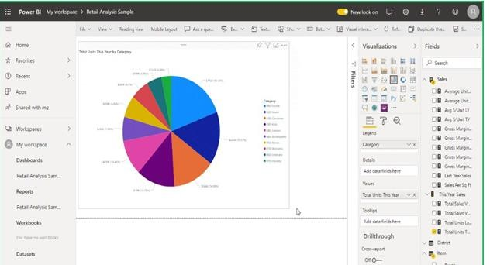

**Step7:**Onthevisualizationspane,*go*tothe**‘Format’**section

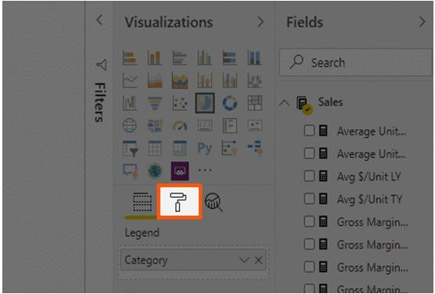

**Step8:**Changetheformatofyour visuals;

[Toenlargethetext,simplygothroughthe‘Legend’,‘Detaillabels’,and‘Title’ and then *adjust* the text size]

**Step9:**Saveyourreportby*clicking***‘File’**fromthetablistand*select***‘Save’**

# OUTPUT:

**RESULT:**

Thedesignareportaanalystissuccessfully.

# AIM:

**EX.NO:14**

**DATE:**

**DASHBOARDANDPERFORMDATAANALYSIS.**

Tocreateadashboardandperformdataanalysis.

# PROCEDURE:

**Step1:**LaunchPowerBIdesktop

**Step2:**Importthefoldercontaining all CSVsinto PowerBIby selecting “***Get Data****”* optionfromthetopribbon,“***More***”fromthebottom,then,selectaddfolderand input the path of the folder.

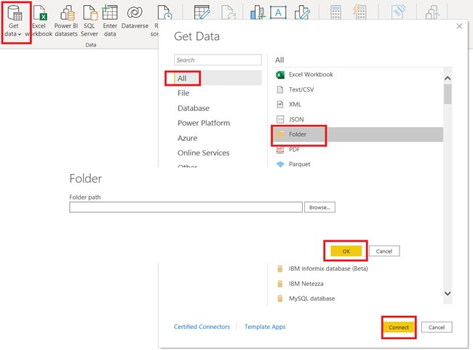

**Step3:**Select“combineandtransform”option,Click OK

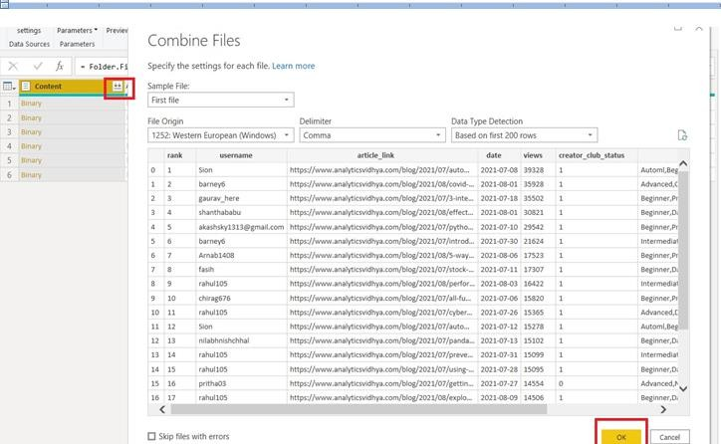

**Step4:**Select***“rank”,“article_link”,andanextra“123”***columnsandright- click to get display theoption to remove the columns.

**Step5:*Right-click***onthecolumnname,select***“Replacevalues”***and**input**

***“.csv”***invaluetofind andleavereplacementvalue.

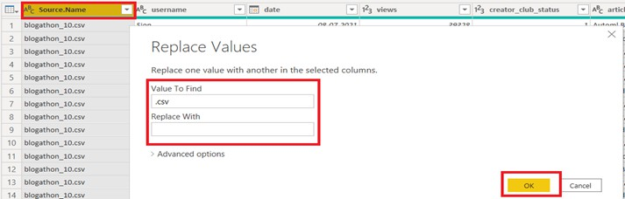

**Step6:**Clickcloseandapplytogetthetransformeddataintothereport.

**Step7:**CreatingvisualizationsforDataAnalysis;

***Adding Numeric Cards***: For our case, we willadd ***Total views, Authors, and Articlecountcards***.Toadd acard,simplydragitfromthevisualizationpaneonthe

right.Then,right-clickonthedatasource,selectthenewmeasureoption,and input the format/formula for the same.

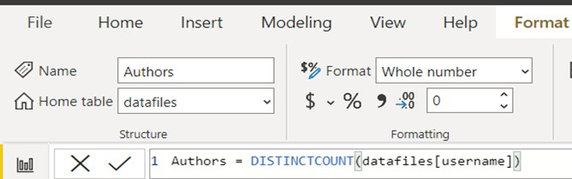

**Step8:**Pickanynon-nullcolumnfromthedata.anddragthemeasuresintoindividual cards.

**Step9:**Plottheviewsofthearticlebythedateofpublishing.

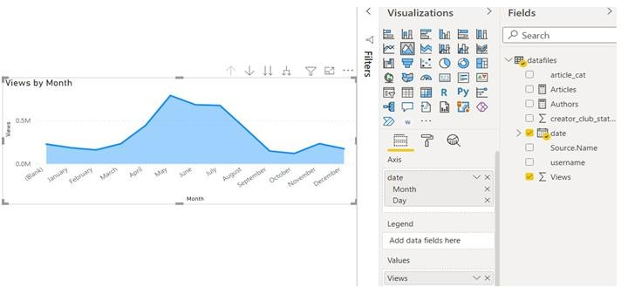

## Step9:AddingWordCloud;

clickonthreedots,select ***“Getmorevisuals”***andinthemarketplace,searchforthe wordcloud. You will see an official Microsoft visual. Click get it now to install**.**

Then,***Dragthearticlescategoriescolumn***intothewordcloudcategoryoptionto generateword cloud.

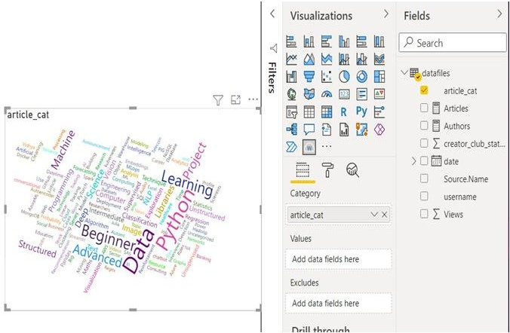

## Step10:AddingCreatorClubPieChart;

***Dragthepiechart***visualonthereport

Nextup,**selecttheusername**(distinct)***asvalues***and***creatorclubstatus***asa

*legend.*

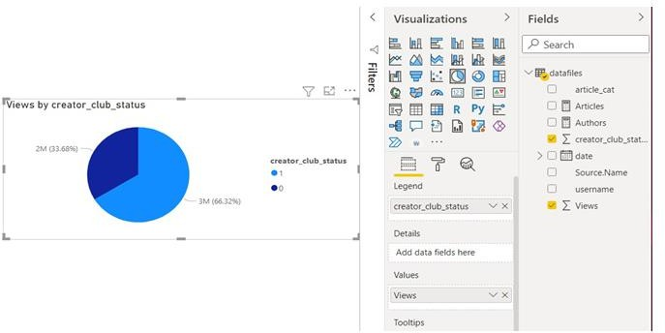

## Step11:AddingSlicerstosortthe data;

Forourdataset,wewilladd***twoslicers***:Onefortheblogathoneditionsorthedata source andthe second one for the usernames column or the authors.

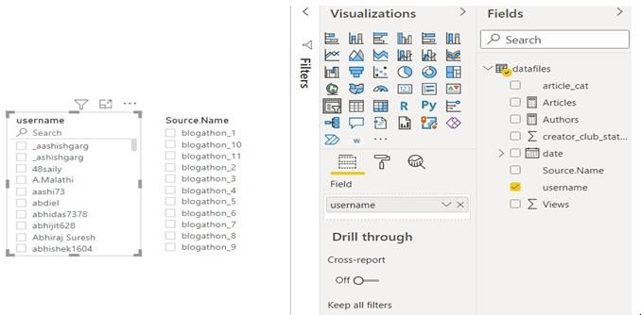

# OUTPUT:

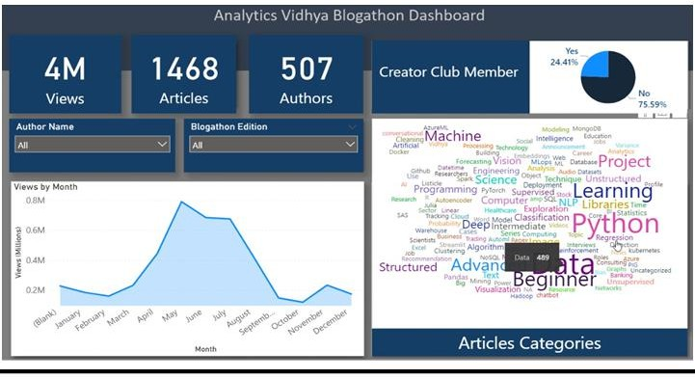

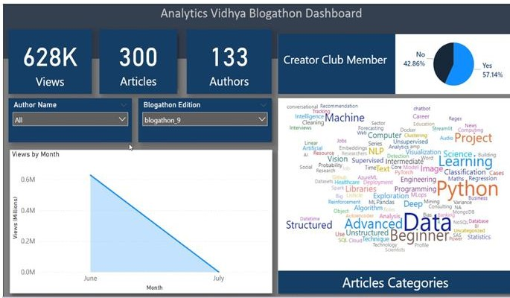

**RESULT:**

Thecreateadashboardandperformdataanalysisissuccessfully.

# AIM:

**EX.NO:15**

**DATE:**

**PREENTATIONOFACASESTUDY**

## Topresentationofacasestudy PROEDURE:

**Step1:DataCollection**

Begin by collecting the Apple stock price dataset from Kaggle or any other reliable source. Ensure that the dataset includes relevant information such as date, open price, close price, highprice, low price, and volume.



## Step2:DataCleaningandTransformation

ImportthedatasetintoPowerBIandperformdatacleaningandtransformation.This may include handling missing data, removing duplicates, and converting data types.

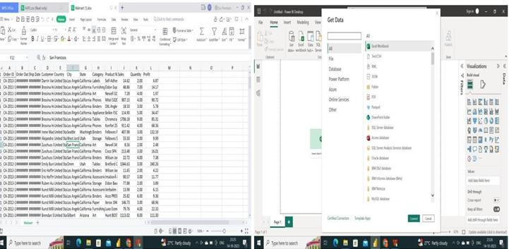

## Step3:DataExploration

Create visualizations to explore the dataset. Common visualizations for stock data analysis include line charts to visualize stock price trends over time, bar charts fortrading volume, and candlestick charts to show open, close, high, and low prices.

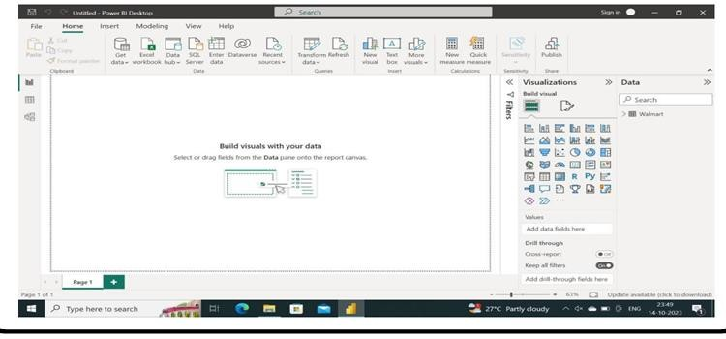

## Step4:StockPriceTrends

UsePowerBItoanalyzeandpresenttrendsinApple'sstockprices.Youcancreateline charts to illustrate daily, weekly, or monthly price trends. Identify key events or periodsthat affected the stock price and add annotations to your visualizations to explain them.

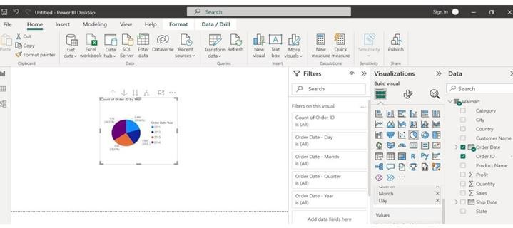

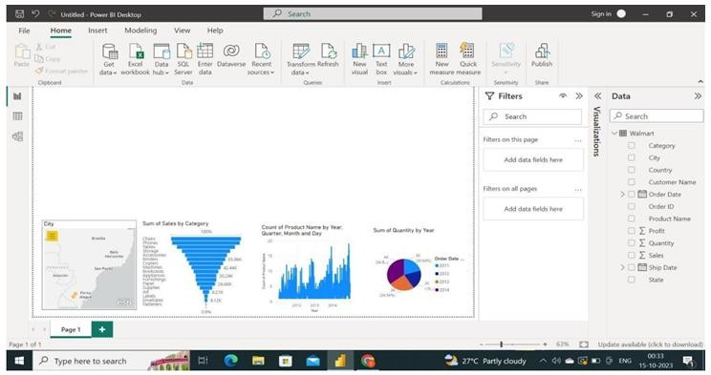

## Step5:DashboardCreation

Create a user-friendly dashboard in Power BI that includes all your visualizations, key insights,andexplanations.Designthedashboardtotellacompellingstoryabout Apple'sstock price performance.

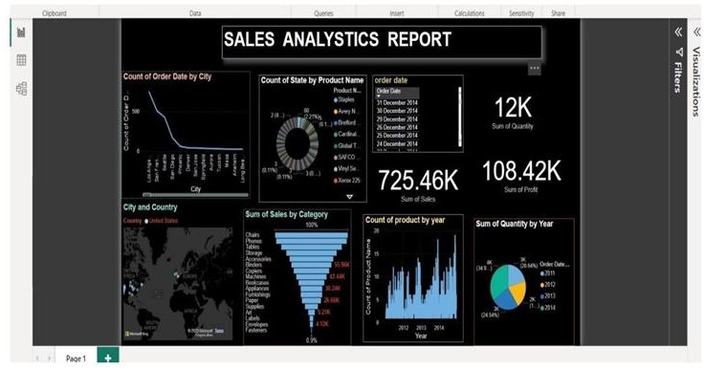

# RESULT:

**Thepresentationofacasestudyis successfully.**